Module name:tedting using testlink and bugzila
Test case ID:TC_01
Webpage URL: www.bugzilla.com, www.TestLink.com

Scenario ID:1a

Scenario:TestLink Project Setup
Test steps :

Verify user can create a new test project in TestLink

Screenshots:

- 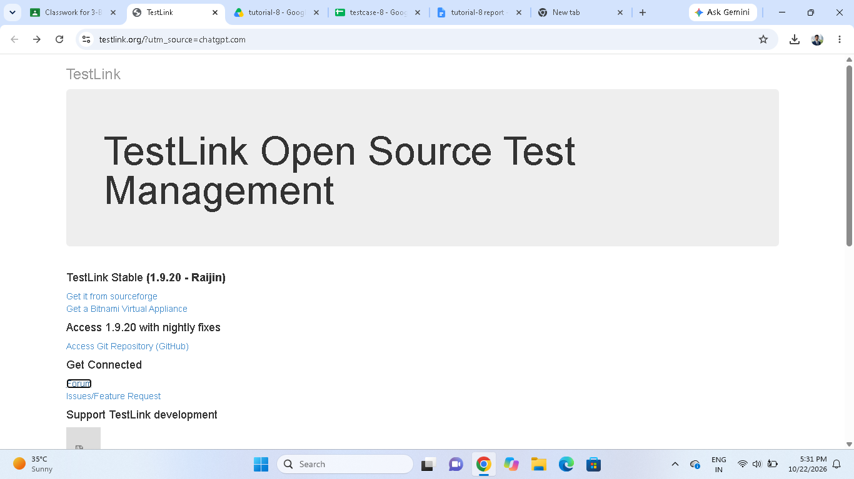

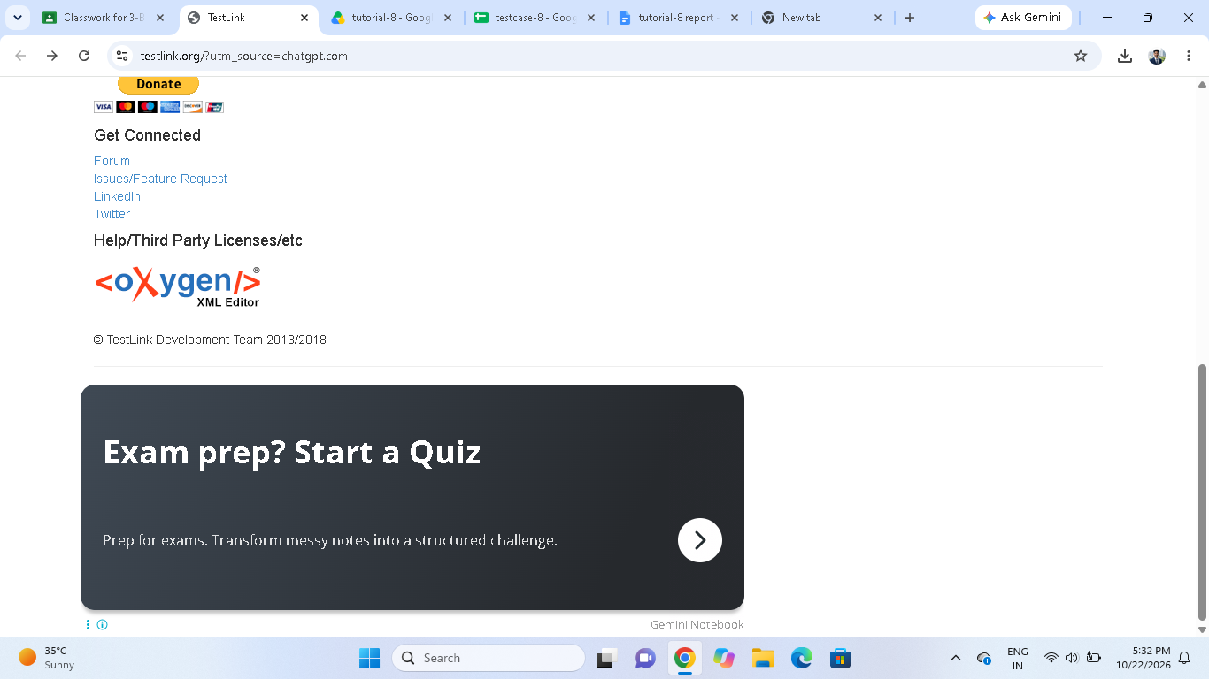

Scenario ID:1b

Scenario:Test Suite Creation
Test steps :

Verify user can create a test suite under the project

Screenshots:

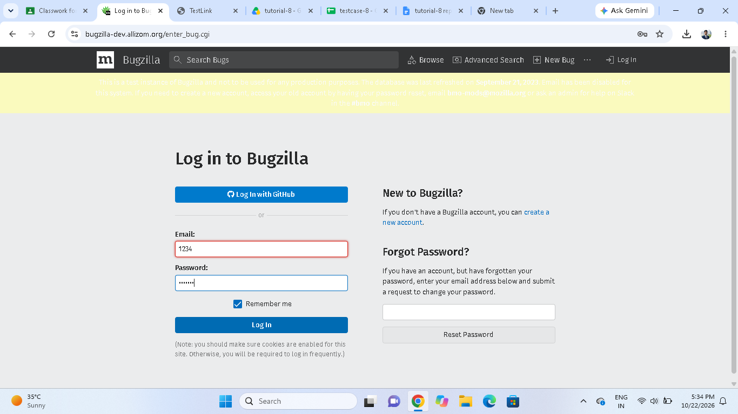

Scenario ID:1c

Scenario:Test Execution (Pass)
Test steps :

Verify user can execute a test case and mark it as Pass

Screenshots:

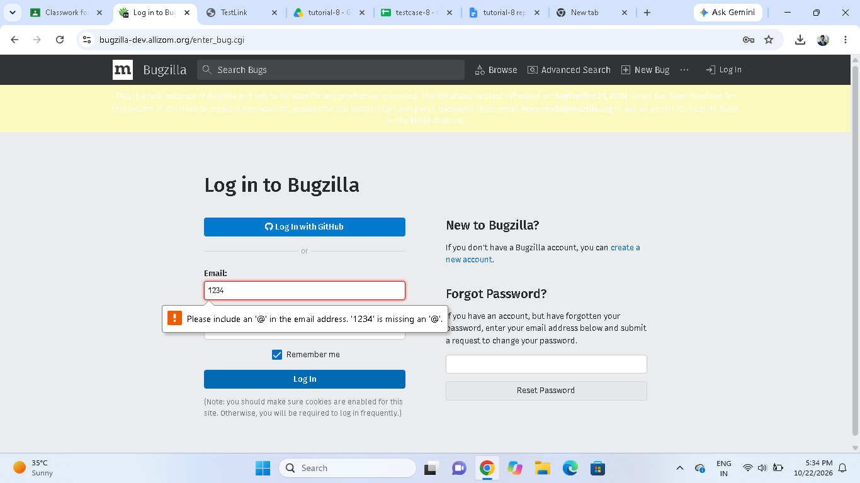

Scenario ID:1d

Scenario:Test Execution (Fail)
Test steps :

Verify user can execute a test case and mark it as Fail

Screenshots:

Scenario ID:1e

Scenario:Defect Creation
Test steps :

Verify user can report/create a new defect in Bugzilla

Screenshots:

Scenario ID:2a

Scenario:Assign Severity
Test steps :

Verify user can assign severity level to the created defect

Screenshots:

